Empirical Analysis of Sorting Algorithms

# 1. Introduction

The aim of this experiment is to compare the performance of three popular sorting algorithms: Bubble Sort, Merge Sort, and Quick Sort. By evaluating their execution time on datasets of different sizes and orders, we aim to identify which algorithm performs best in various scenarios and understand the practical implications of their theoretical complexities.

# 2. Methodology and Environment

The time taken by each sorting algorithm was measured using high-resolution clock functions in C++.

Each algorithm was tested on datasets of sizes 10, 1000, and 10000, with three data types: random, sorted, and reverse sorted.

• Programming Language : C++

• Time Measurement Library : <chrono>

• Execution Method :

auto start = high_resolution_clock::now();

// sorting...

auto end = high_resolution_clock::now();

duration<double> duration = end - start;

• Operating System: Windows 10 Pro

• Device Specifications: HP 255 G8 Notebook PC, AMD Athlon Silver 3050U with Radeon Graphics @ 2.30GHz, 8GB RAM, 64-bit OS

# 3. Results

Below is a summary table of the average execution times (in seconds) for each algorithm:

|  |  |  |  |
| --- | --- | --- | --- |
| Algorithm | Input Size | Type | Average Time (s) |
| BubbleSort | 10 | random | 8.38333e-07 |
| MergeSort | 10 | random | 3.09967e-06 |
| QuickSort | 10 | random | 5.85333e-07 |
| BubbleSort | 10 | sorted | 3.43667e-07 |
| MergeSort | 10 | sorted | 2.53133e-06 |
| QuickSort | 10 | sorted | 1.01067e-06 |
| BubbleSort | 10 | reverse | 8.82333e-07 |
| MergeSort | 10 | reverse | 2.51033e-06 |
| QuickSort | 10 | reverse | 7.24333e-07 |
| BubbleSort | 1000 | random | 0.00689557 |
| MergeSort | 1000 | random | 0.000430956 |
| QuickSort | 1000 | random | 0.00017465 |
| BubbleSort | 1000 | sorted | 0.00228054 |
| MergeSort | 1000 | sorted | 0.000356647 |
| QuickSort | 1000 | sorted | 0.00688135 |
| BubbleSort | 1000 | reverse | 0.00757002 |
| MergeSort | 1000 | reverse | 0.000416656 |
| QuickSort | 1000 | reverse | 0.00448687 |
| BubbleSort | 10000 | random | 0.696608 |
| MergeSort | 10000 | random | 0.00537519 |
| QuickSort | 10000 | random | 0.00215895 |
| BubbleSort | 10000 | sorted | 0.245528 |
| MergeSort | 10000 | sorted | 0.00402343 |
| QuickSort | 10000 | sorted | 0.471403 |
| BubbleSort | 10000 | reverse | 0.787775 |
| MergeSort | 10000 | reverse | 0.00424259 |
| QuickSort | 10000 | reverse | 0.318238 |

The following chart visualizes the performance of each algorithm on random data: 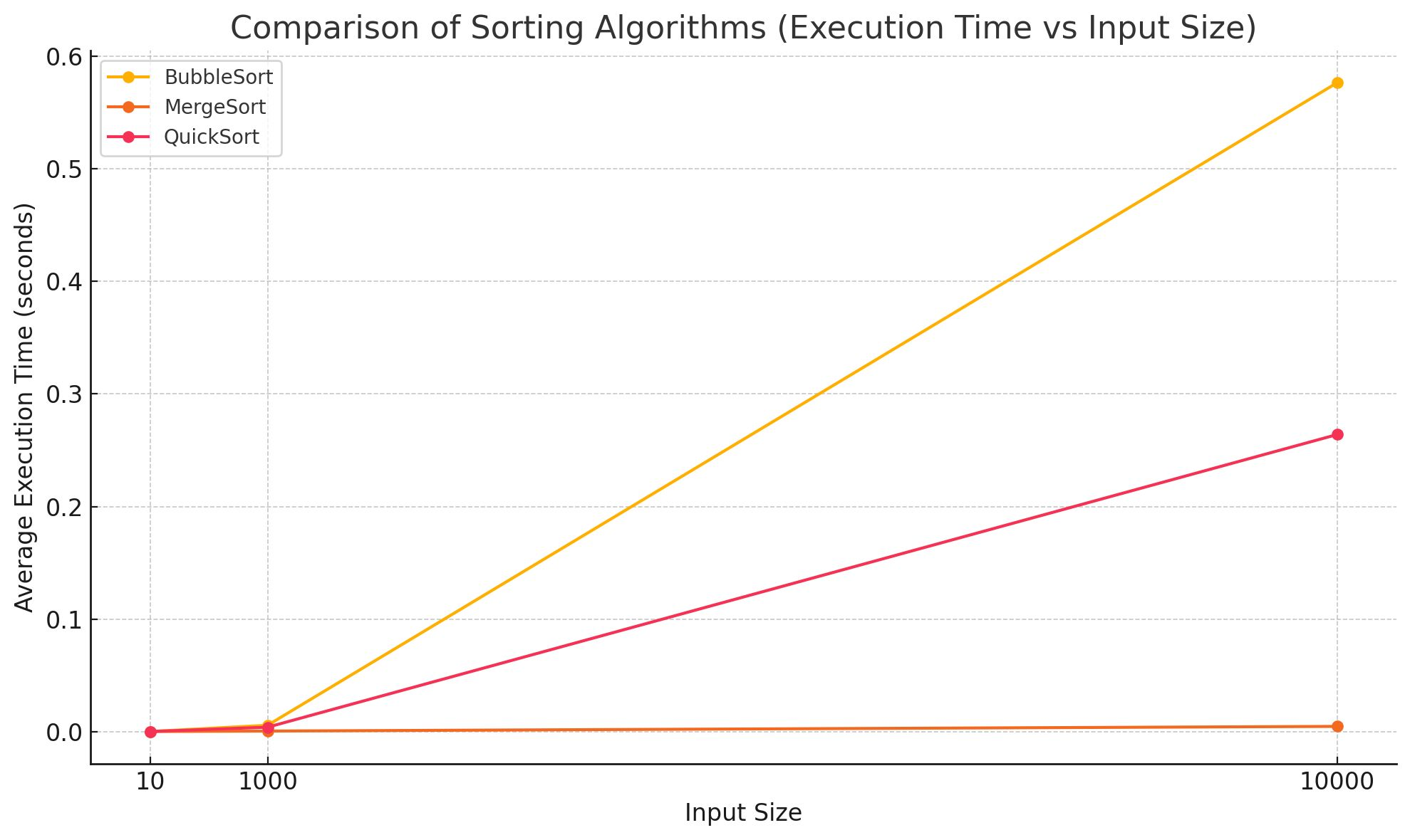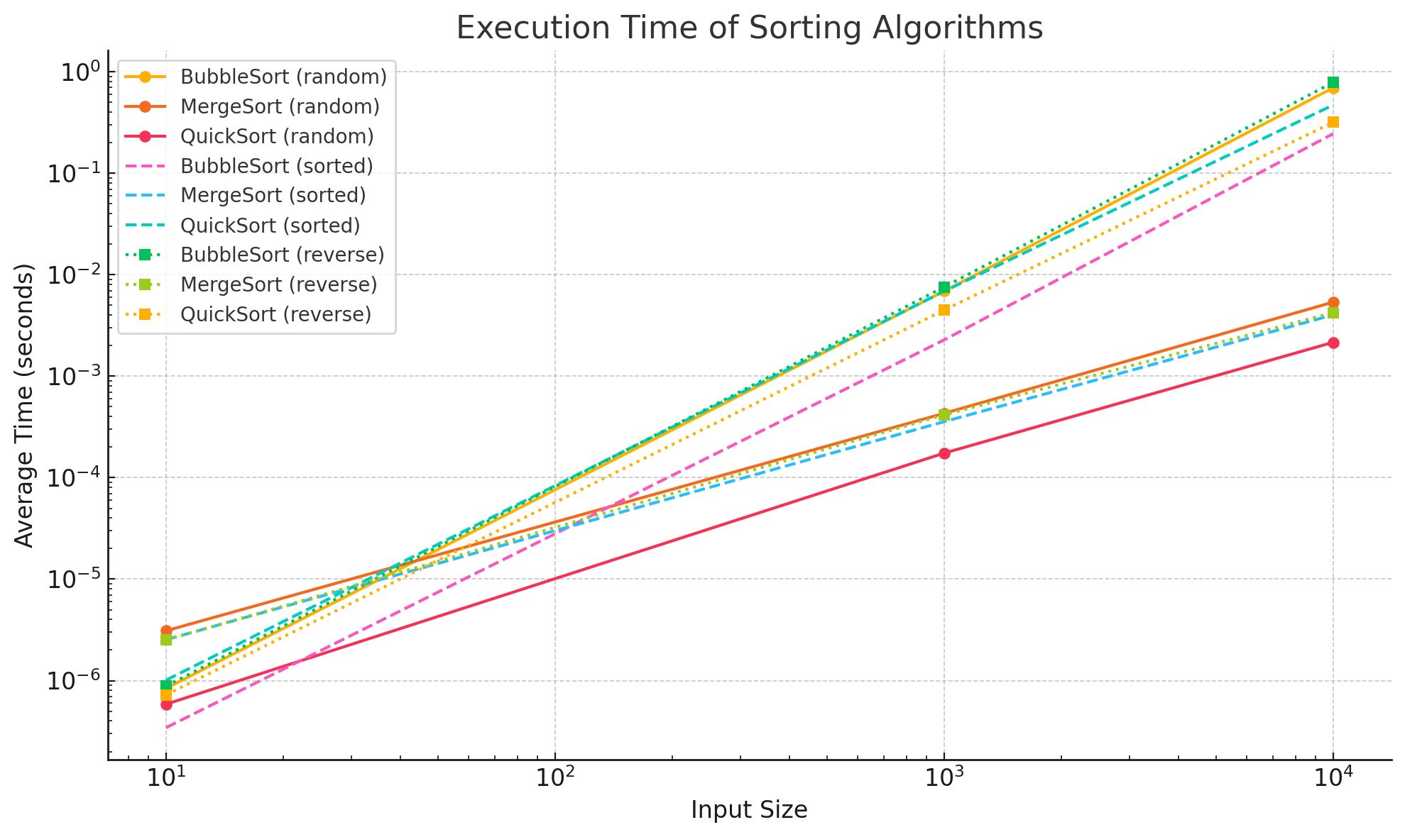

# 4. Analysis and Discussion

* Bubble Sort is a simple sorting algorithm but performs poorly in practice, especially with large datasets.   
  It has a best case of O(n) when the array is already sorted, but its average and worst case are O(n²), making it inefficient.
* Merge Sort guarantees O(n log n) performance regardless of the input and is known for its stability.   
  It is efficient and widely used in scenarios where stable sorting is needed.
* Quick Sort, despite having a worst case of O(n²), is often the fastest in practice due to its in-place sorting and good cache

performance. Its average and best case are O(n log n), making it highly efficient for large datasets

# Comparison and Analysis of Sorting Algorithms

## Time Complexity and Performance Comparison

|  |  |  |  |  |
| --- | --- | --- | --- | --- |
| Algorithm | Best Case (Big O) | Average Case (Big O) | Worst Case (Big O) | Practical Performance |
| Bubble Sort | O(n) | O(n²) | O(n²) | Very slow |
| Merge Sort | O(n log n) | O(n log n) | O(n log n) | Stable and fast |
| Quick Sort | O(n log n) | O(n log n) | O(n²) | Usually the fastest |

## 5. Conclusion

In conclusion, Quick Sort generally provides the best performance for most practical scenarios, making it the most suitable choice for large and randomly ordered datasets. Merge Sort is more stable in terms of performance and suitable for situations where consistent execution time is required. Bubble Sort should be avoided for large datasets due to its poor scalability.

Dr : thaer thaher

Student id : 202210677

Student name : kinda massad

" Wish me luck "